TITLE: - SUM OF 1 TO 10

AIM: -
To write a ALP to sum numbers from 1 to 10 and display the result on screen.
ALGORITHM: -
· Initialize data segment register.
· Set CX = 10 and AX = 0.
· Add CX to AX and repeat using LOOP until CX = 0.
· Save the sum on stack.
· Display the message string.
· Restore the sum into AX.
· Convert the sum to decimal by repeated division by 10 and store digits on stack.
· Pop digits, convert to ASCII, and display them.
PROGRAM: -
TITLE SUM.ASM -- Program to sum of 1 to 10
;//***********************************************************************
;//* *
;//* Copyright (c) 1985-2022, American Megatrends International LLC. *
;//* *
;//* All rights reserved. Subject to AMI licensing agreement. *
;//* *
;//***********************************************************************
;<AMI_FHDR_START>
;
; Header:
; Author: Muthuganesh s
; Description: Program to sum numbers from 1 to 10 and display result
; Date: 28/03/2026
;
;<AMI_FHDR_END>
;*************************************************************************

.model small
.stack 100h

;----------------------------------------------------------------------------
; DATA SEGMENT
;----------------------------------------------------------------------------
data segment

msg db "Sum of numbers from 1 to 10 is: $"

data ends
;----------------------------------------------------------------------------

;----------------------------------------------------------------------------
; CODE SEGMENT
;----------------------------------------------------------------------------
code segment
assume cs:code, ds:data

start:

; Initialize Data Segment
mov ax, data
mov ds, ax

;----------------------------------------
; Initialize registers
;----------------------------------------
mov cx, 10 ; Counter (10 numbers)
mov ax, 0 ; AX will store sum

;----------------------------------------
; Loop to calculate sum
;----------------------------------------
sum_loop:
add ax, cx ; AX = AX + CX
loop sum_loop ; CX = CX - 1, repeat until CX = 0

; At this point AX = 55

; ---> FIX ADDED HERE: Save the sum before printing the message
push ax

;----------------------------------------
; Display message
;----------------------------------------
mov dx, offset msg
mov ah, 09h
int 21h

; ---> FIX ADDED HERE: Restore the sum back into AX
pop ax

;----------------------------------------
; Convert number (AX) to decimal digits
;----------------------------------------
mov bx, 10 ; Divisor = 10
mov cx, 0 ; Digit counter

convert_loop:
xor dx, dx ; Clear DX before division
div bx ; AX ÷ 10 → Quotient in AX, Remainder in DX

push dx ; Save remainder (digit)
inc cx ; Count digits

cmp ax, 0
jne convert_loop ; Continue until quotient = 0

;----------------------------------------
; Display digits (reverse order)
;----------------------------------------
print_loop:
pop dx ; Get digit
add dl, '0' ; Convert to ASCII

mov ah, 02h
int 21h

loop print_loop

;----------------------------------------
; Exit program
;----------------------------------------
mov ah, 4Ch
int 21h

code ends
end start
;----------------------------------------------------------------------------
OUTPUT: -
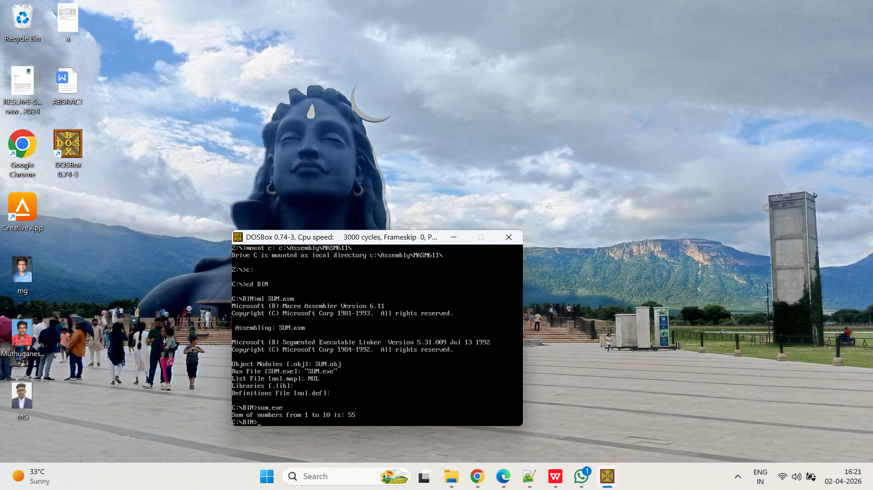
TITLE: - FIND A CHARACTER IN STRING

AIM: -
To write program to find a character in string using ALP.
ALGORITHM:-
· Initialize the data segment register.
· Display prompt to enter a string.
· Read the string using DOS function 0Ah.
· Display prompt to enter a character.
· Read a single character using DOS function 01h.
· Store the input character in a variable.
· Initialize pointer to the start of the input string.
· Compare each character of the string with the search character.
· If match is found, display “Character Found”.
· If end of string (Carriage Return) is reached, display “Character Not Found”.

PROGRAM:-
TITLE CHAR.ASM -- Program to find a character in a user-input string

;//***********************************************************************
;//* *
;//* Copyright (c) 1985-2022, American Megatrends International LLC. *
;//* *
;//* All rights reserved. Subject to AMI licensing agreement. *
;//* *
;//***********************************************************************
;<AMI_FHDR_START>
;
; Header:
; Author: Muthuganesh s
; Description: Program to take string and character input and search
; Date: 28/03/2026
;
;<AMI_FHDR_END>
;*************************************************************************

.model small
.stack 100h

;----------------------------------------------------------------------------
; DATA SEGMENT
;----------------------------------------------------------------------------
data segment

prompt1 db "Enter a string: $"
prompt2 db 13, 10, "Enter a character to search for: $"

msg1 db 13, 10, "Character Found!$"
msg2 db 13, 10, "Character Not Found.$"

;--------------------------------------------------
; Buffer structure for reading a string via AH=0Ah
;--------------------------------------------------
input_buffer db 50 ; Byte 0: Max characters allowed to read
actual_len db ? ; Byte 1: Actual characters read (filled by DOS)
user_string db 50 dup(?) ; Byte 2+: The actual string data entered
search_char db ? ; Variable to hold the single character
data ends
;----------------------------------------------------------------------------
; CODE SEGMENT
;----------------------------------------------------------------------------
code segment
assume cs:code, ds:data
start:
; Initialize Data Segment
mov ax, data
mov ds, ax
;--------------------------------------------------
; 1. Prompt user for string
;--------------------------------------------------
mov dx, offset prompt1
mov ah, 09h
int 21h

;--------------------------------------------------
; 2. Read string from user
;--------------------------------------------------
mov dx, offset input_buffer
mov ah, 0Ah
int 21h
;--------------------------------------------------
; 3. Prompt user for character
;--------------------------------------------------
mov dx, offset prompt2
mov ah, 09h
int 21h
;--------------------------------------------------
; 4. Read single character from user
;--------------------------------------------------
mov ah, 01h
int 21h
mov search_char, al ; Save the typed character into our variable
;--------------------------------------------------
; 5. Initialize for Search
;--------------------------------------------------
lea si, user_string ; Point SI to the start of the typed string
mov al, search_char ; Load the character we are looking for into AL
search_loop:
mov bl, [si] ; Load current character from string

cmp bl, 0Dh ; Did we hit Carriage Return? (0Dh is the end of user input)
je not_found ; If yes, we reached the end without finding it
cmp bl, al ; Compare string character with search character
je found ; If equal, jump to found
inc si ; Move to next character
jmp search_loop ; Repeat loop
;--------------------------------------------------
; If character is found
;--------------------------------------------------
found:
mov dx, offset msg1 ; Load "Found" message
mov ah, 09h
int 21h
jmp exit_program
;--------------------------------------------------
; If character is not found
;--------------------------------------------------
not_found:
mov dx, offset msg2 ; Load "Not Found" message
mov ah, 09h
int 21h
;--------------------------------------------------
; Exit program
;--------------------------------------------------
exit_program:
mov ah, 4Ch
int 21h
code ends
end start
;----------------------------------------------------------------------------
OUTPUT:-.
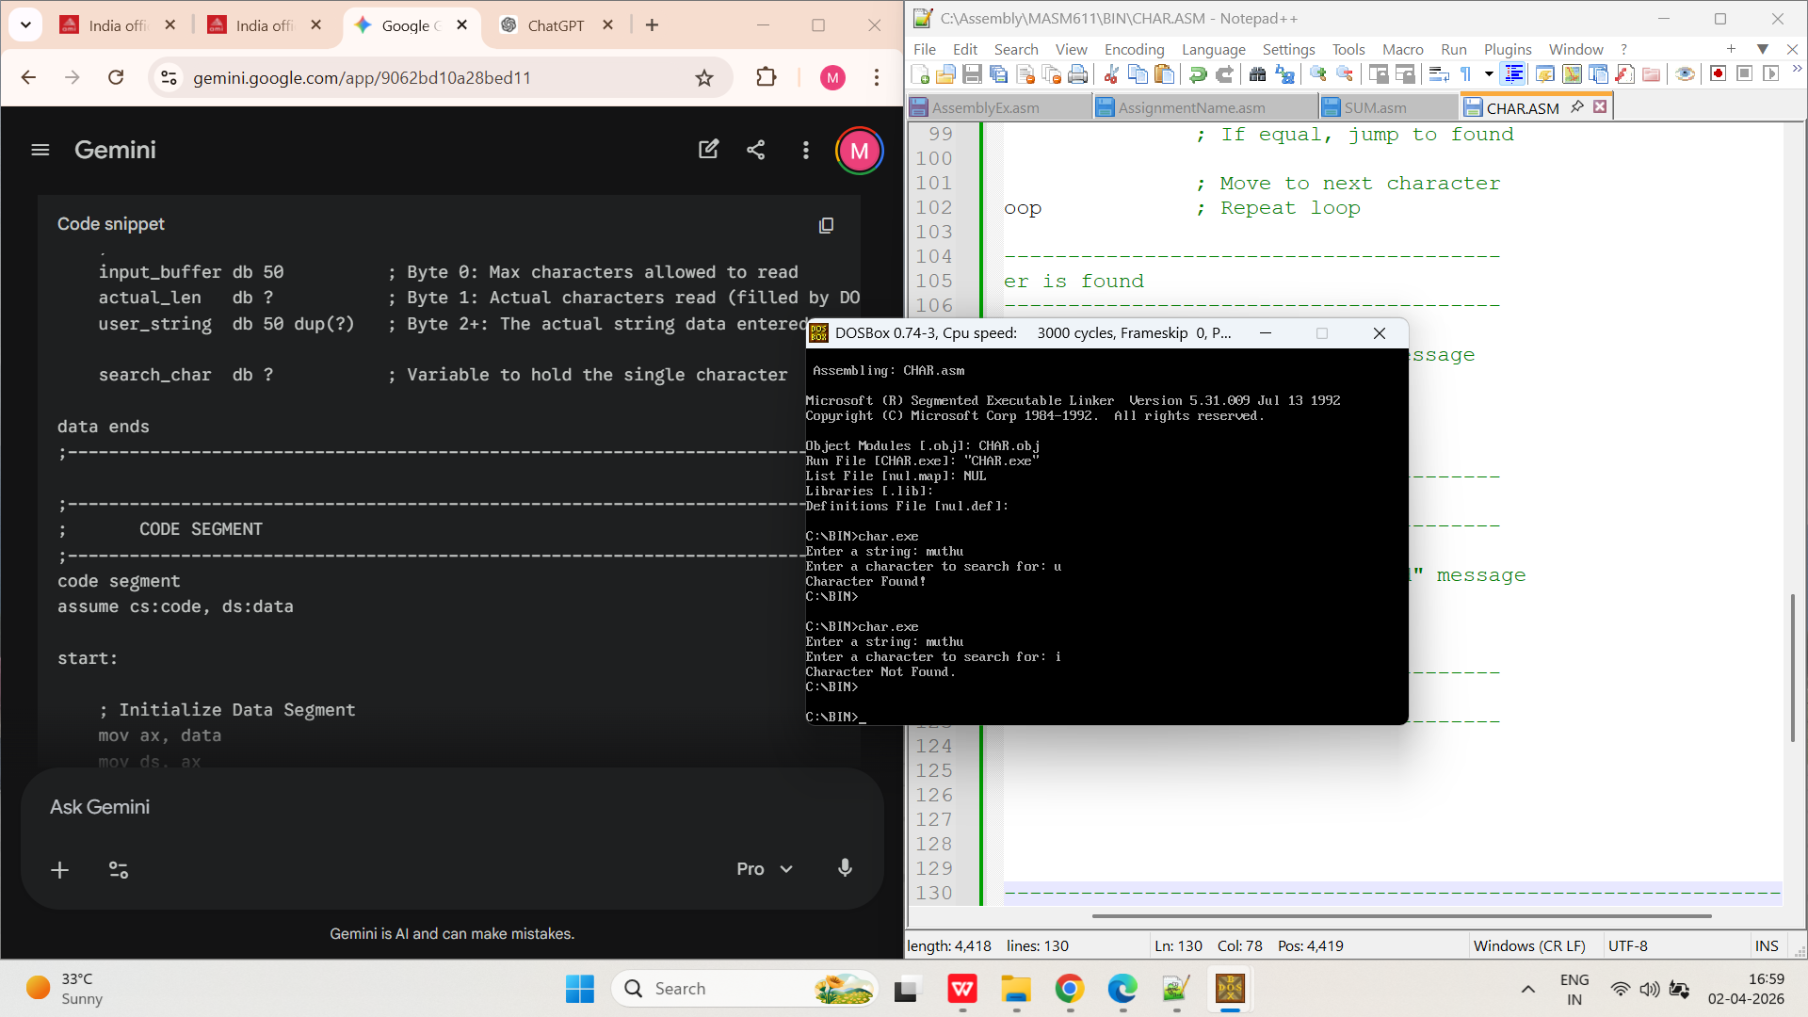

TITLE: - REVERSE A STRING

AIM: -
To write a ALP program to reverse a string.
ALGORITHM:-
· Initialize the data segment register.
· Display prompt to enter a string.
· Read the string using DOS function 0Ah.
· Check if the string length is zero; if yes, terminate.
· Load string length into CX and point to string start.
· Push each character of the string onto the stack.
· Reset pointer and counter to the beginning of the string.
· Pop characters from the stack and store back into the string.
· Append $ at the end of the reversed string.
· Display result message.
· Display the reversed string.

PROGRAM:
TITLE REV.ASM -- Program to reverse a string

;//***********************************************************************
;//* *
;//* Copyright (c) 1985-2022, American Megatrends International LLC. *
;//* *
;//* All rights reserved. Subject to AMI licensing agreement. *
;//* *
;//***********************************************************************
;<AMI_FHDR_START>
;
; Header:
; Author: Muthuganesh s
; Description: Program to take a user string, reverse it using the stack, and display it.
; Date: 02/04/2026
;
;<AMI_FHDR_END>
;*************************************************************************

.model small
.stack 100h

;----------------------------------------------------------------------------
; DATA SEGMENT
;----------------------------------------------------------------------------
data segment

prompt db "Enter a string to reverse: $"
msg db 13, 10, "Reversed string: $"

;--------------------------------------------------
; Buffer structure for reading a string via AH=0Ah
;--------------------------------------------------
input_buffer db 50 ; Byte 0: Max characters allowed
actual_len db ? ; Byte 1: Actual characters typed
user_string db 50 dup(?) ; Byte 2+: The string data

data ends
;----------------------------------------------------------------------------

;----------------------------------------------------------------------------
; CODE SEGMENT
;----------------------------------------------------------------------------
code segment
assume cs:code, ds:data

start:

;--------------------------------------------------
; Initialize Data Segment
;--------------------------------------------------
mov ax, data
mov ds, ax

;--------------------------------------------------
; Prompt user for string
;--------------------------------------------------
mov dx, offset prompt
mov ah, 09h
int 21h

;--------------------------------------------------
; Read string from user
;--------------------------------------------------
mov dx, offset input_buffer
mov ah, 0Ah
int 21h

;--------------------------------------------------
; Check if string is empty
;--------------------------------------------------
mov cl, actual_len ; Load actual length of typed string into CL
cmp cl, 0 ; Did the user just press Enter?
je exit_program ; If yes, just exit

mov ch, 0 ; Clear CH so CX contains the full 16-bit length
lea si, user_string ; Point SI to the start of the typed string

;--------------------------------------------------
; Step 1: PUSH all characters onto the stack
;--------------------------------------------------
push_loop:
mov al, [si] ; Get a character from the string
mov ah, 0 ; Clear AH (because we must push a 16-bit AX register)
push ax ; Push the character onto the stack
inc si ; Move to the next character in the string
loop push_loop ; Repeat until CX becomes 0

;--------------------------------------------------
; Step 2: POP characters back into the string
;--------------------------------------------------
mov cl, actual_len ; Reset CX back to the string length
mov ch, 0
lea si, user_string ; Reset SI back to the start of the string

pop_loop:
pop ax ; Pop the top character from the stack
mov [si], al ; Overwrite the string memory with the reversed character
inc si ; Move to the next memory slot
loop pop_loop ; Repeat until CX becomes 0

; Add '$' at the end of the newly reversed string so DOS knows where to stop printing
mov byte ptr [si], '$'

;--------------------------------------------------
; Print the result message
;--------------------------------------------------
mov dx, offset msg
mov ah, 09h
int 21h

;--------------------------------------------------
; Print the reversed string
;--------------------------------------------------
mov dx, offset user_string
mov ah, 09h
int 21h
;--------------------------------------------------
; Exit program
;--------------------------------------------------
exit_program:
mov ah, 4Ch
int 21h
code ends
end start
;----------------------------------------------------------------------------
OUTPUT:
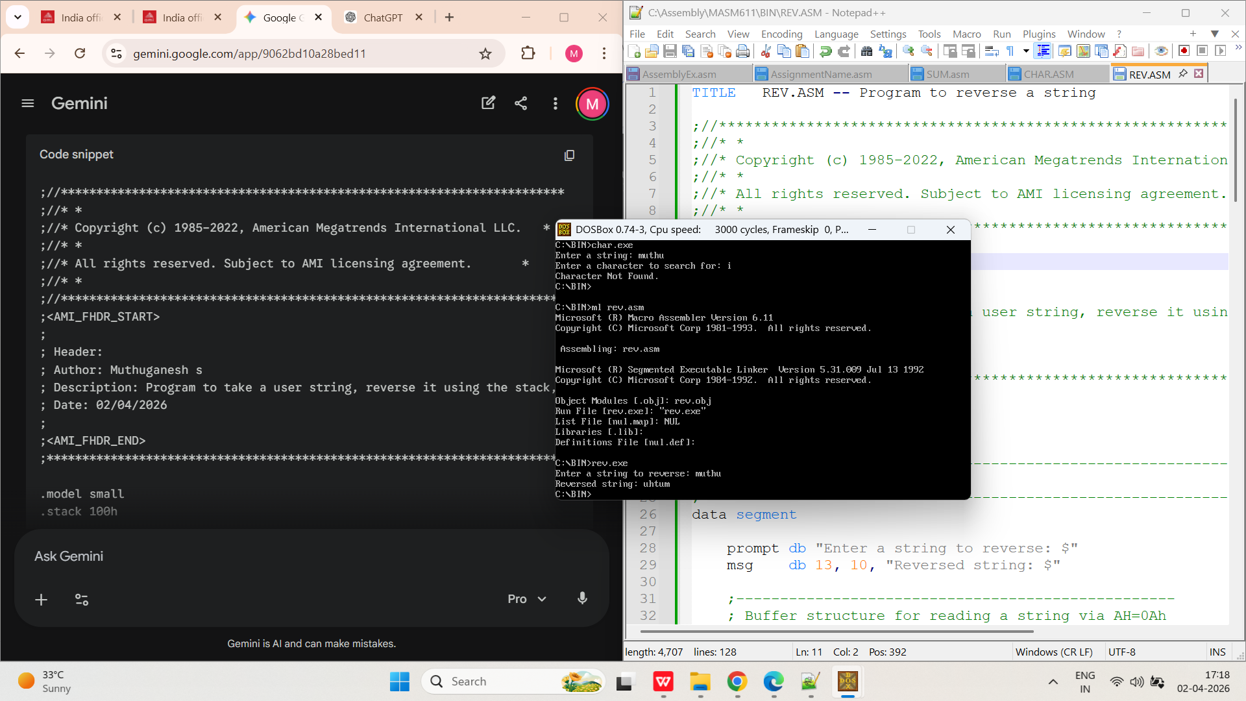
TITLE: - PROGRAM TO COUNT 1S IN A BYTE

AIM: -
To write a ALP program to count 1’s in a byte.
ALGORITHM:-
· Initialize the data segment register.
· Display prompt to enter a character.
· Read a character using DOS function 01h.
· Store ASCII value in register AL.
· Set counter CX = 8 for 8 bits.
· Initialize bit count register BL = 0.
· Shift AL left by one bit.
· If Carry Flag is set, increment BL.
· Repeat steps 8–9 for all 8 bits using loop.
· Display result message.
· Convert count to ASCII and display it.

PROGRAM:
TITLE BIT.ASM -- Program to count 1s in a byte

;//***********************************************************************
;//* *
;//* Copyright (c) 1985-2022, American Megatrends International LLC. *
;//* *
;//* All rights reserved. Subject to AMI licensing agreement. *
;//* *
;//***********************************************************************
;<AMI_FHDR_START>
;
; Header:
; Author: Muthuganesh s
; Description: Program to count the number of 1 bits in a user-input byte
; Date: 02/04/2026
;
;<AMI_FHDR_END>
;*************************************************************************

.model small
.stack 100h

;----------------------------------------------------------------------------
; DATA SEGMENT
;----------------------------------------------------------------------------
data segment

prompt db "Enter a single character: $"
msg db 13, 10, "Number of 1 bits in its ASCII value is: $"

data ends
;----------------------------------------------------------------------------
;----------------------------------------------------------------------------
; CODE SEGMENT
;----------------------------------------------------------------------------
code segment
assume cs:code, ds:data
start:
;--------------------------------------------------
; Initialize Data Segment
;--------------------------------------------------
mov ax, data
mov ds, ax

;--------------------------------------------------
; Prompt user for a character
;--------------------------------------------------
mov dx, offset prompt
mov ah, 09h
int 21h

;--------------------------------------------------
; Read a single character from user
;--------------------------------------------------
mov ah, 01h
int 21h
; The ASCII value of the typed character is now in AL
;--------------------------------------------------
; Setup for counting bits
;--------------------------------------------------
mov cx, 8 ; Loop 8 times (since a byte has 8 bits)
mov bl, 0 ; BL will be our counter for the '1's
;--------------------------------------------------
; Loop to shift and count
;--------------------------------------------------
count_loop:
shl al, 1 ; SHL shifts all bits in AL left by 1.
; The leftmost bit falls into the Carry Flag (CF).
jnc skip_increment ; "Jump if No Carry": If CF is 0, skip the next line

inc bl ; If CF is 1, increment our counter!
skip_increment:
loop count_loop ; Decrease CX. If CX > 0, jump back to count_loop
;--------------------------------------------------
; Display the result message
;--------------------------------------------------
mov dx, offset msg
mov ah, 09h
int 21h
;--------------------------------------------------
; Display the count
;--------------------------------------------------
; Because a byte only has 8 bits, our max count is 8.
; This means we don't need complex division to print it!
; We just add '0' (30h) to convert it to an ASCII character.

mov dl, bl ; Move our count from BL to DL for printing
add dl, '0' ; Convert the number to an ASCII digit ('0' to '8')

mov ah, 02h ; DOS interrupt to print a single character
int 21h
;--------------------------------------------------
; Exit program
;--------------------------------------------------
mov ah, 4Ch
int 21h
code ends
end start
;----------------------------------------------------------------------------
OUTPUT:
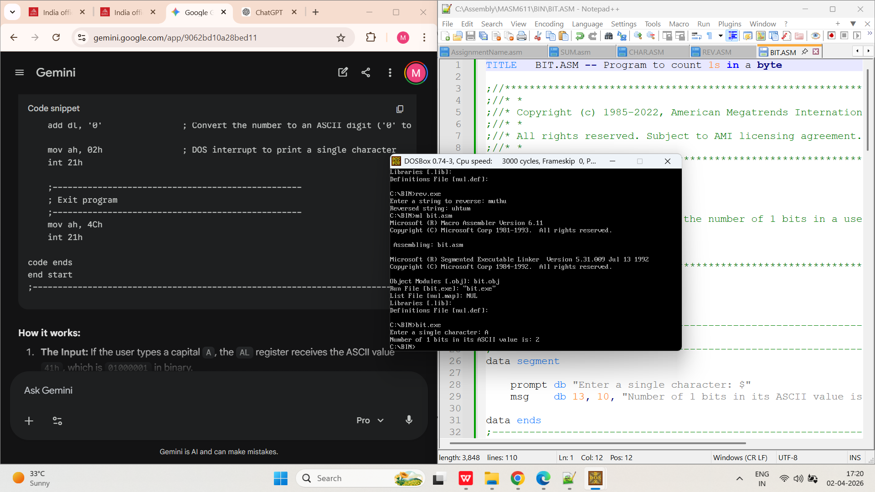
TITLE: - COMAPARE TWO STRINGS
AIM: -
To write a ALP program to compare two strings
PROGRAM:
TITLE COM.ASM -- Compare two strings entered by the user
;//***********************************************************************
;//* *
;//* Copyright (c) 1985-2022, American Megatrends International LLC. *
;//* *
;//* All rights reserved. Subject to AMI licensing agreement. *
;//* *
;//***********************************************************************
;<AMI_FHDR_START>
;
; Header:
; Author: Muthuganesh s
; Description: Take two strings from user and compare them
; Date: 02/04/2026
;
;<AMI_FHDR_END>
;*************************************************************************

.model small
.stack 100h

;----------------------------------------------------------------------------
; DATA SEGMENT
;----------------------------------------------------------------------------
data segment

prompt1 db "Enter the first string: $"
prompt2 db 13, 10, "Enter the second string: $"

msg_eq db 13, 10, 13, 10, "Result: Strings are EQUAL!$"
msg_neq db 13, 10, 13, 10, "Result: Strings are NOT EQUAL.$"

;--------------------------------------------------
; Buffer for String 1
;--------------------------------------------------
buffer1 db 50 ; Byte 0: Max length allowed
len1 db ? ; Byte 1: Actual length typed
str1 db 50 dup(?) ; Byte 2+: The string data

;--------------------------------------------------
; Buffer for String 2
;--------------------------------------------------
buffer2 db 50 ; Byte 0: Max length allowed
len2 db ? ; Byte 1: Actual length typed
str2 db 50 dup(?) ; Byte 2+: The string data

data ends
;----------------------------------------------------------------------------

;----------------------------------------------------------------------------
; CODE SEGMENT
;----------------------------------------------------------------------------
code segment
assume cs:code, ds:data

start:

;--------------------------------------------------
; Initialize Data Segment
;--------------------------------------------------
mov ax, data
mov ds, ax

;--------------------------------------------------
; 1. Get First String
;--------------------------------------------------
mov dx, offset prompt1
mov ah, 09h
int 21h

mov dx, offset buffer1
mov ah, 0Ah
int 21h

;--------------------------------------------------
; 2. Get Second String
;--------------------------------------------------
mov dx, offset prompt2
mov ah, 09h
int 21h

mov dx, offset buffer2
mov ah, 0Ah
int 21h

;--------------------------------------------------
; 3. Compare Lengths First (Optimization)
;--------------------------------------------------
mov al, len1 ; Load length of first string
cmp al, len2 ; Compare with length of second string
jne not_equal ; If lengths are different, strings are definitely not equal

;--------------------------------------------------
; 4. Prepare for Character Comparison
;--------------------------------------------------
mov cl, len1 ; Use the length as our loop counter
cmp cl, 0 ; Are both strings completely empty? (User just pressed Enter twice)
je equal ; If both are empty, technically they are equal!

mov ch, 0 ; Clear CH so CX has the correct 16-bit loop count
lea si, str1 ; Point SI to first string data
lea di, str2 ; Point DI to second string data

;--------------------------------------------------
; 5. Compare Character by Character
;--------------------------------------------------
compare_loop:
mov al, [si] ; Get char from string 1
mov bl, [di] ; Get char from string 2
cmp al, bl ; Compare them
jne not_equal ; If a mismatch is found, exit immediately to 'not_equal'
inc si ; Move to next char in string 1
inc di ; Move to next char in string 2
loop compare_loop ; Decrease CX, and repeat if CX > 0
;--------------------------------------------------
; If the loop finishes naturally, all chars matched!
;--------------------------------------------------
equal:
mov dx, offset msg_eq
mov ah, 09h
int 21h
jmp exit_program

;--------------------------------------------------
; If lengths differ or a char mismatch was found
;--------------------------------------------------
not_equal:
mov dx, offset msg_neq
mov ah, 09h
int 21h
;--------------------------------------------------
; Exit program
;--------------------------------------------------
exit_program:
mov ah, 4Ch
int 21h
code ends
end start
;----------------------------------------------------------------------------
OUTPUT:
